**CMPE 207 : Network Programming and Applications**

**Homework 3: Chat App Submitted by Team Network Ninjas (Shashank Bheemanapalli, Vidhatri Milind Joshi and Sahiti Shankar Varada)**

**chat_server code :**

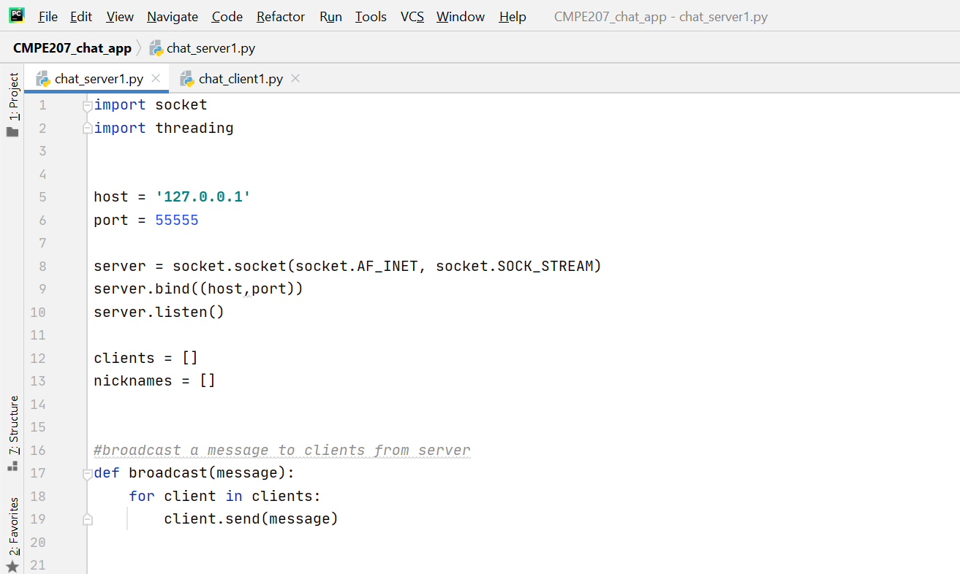

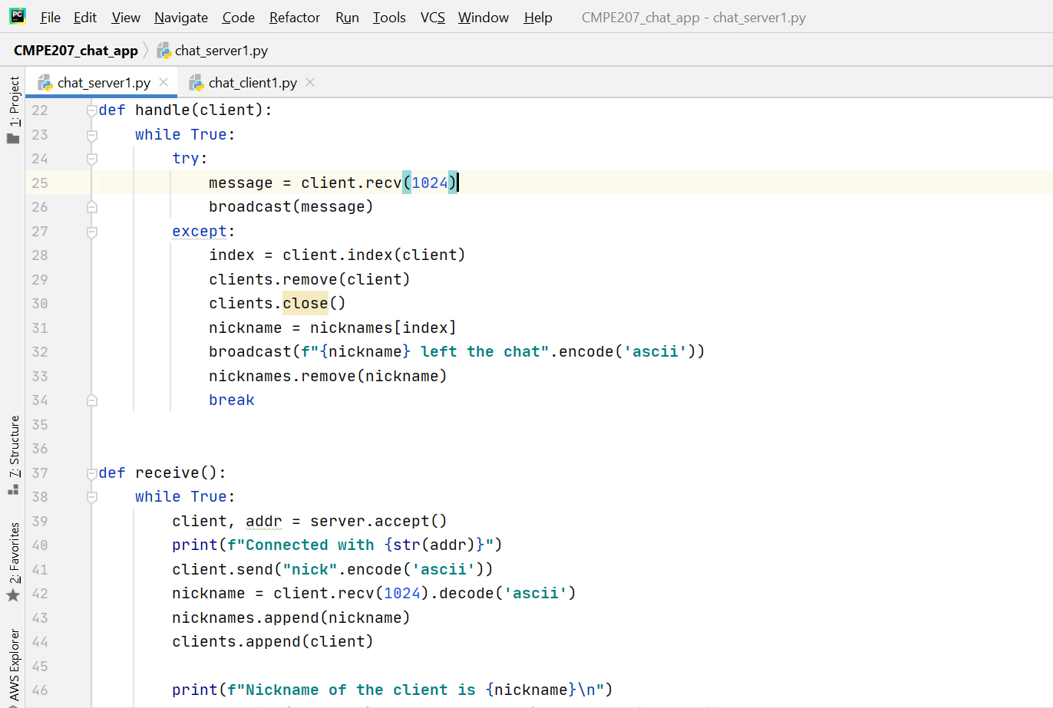

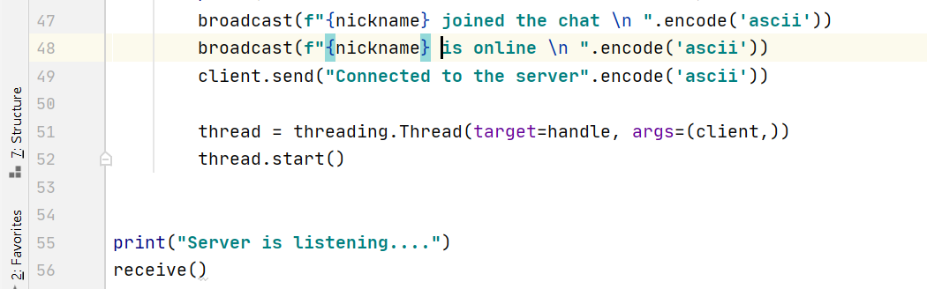

**chat_client code:**

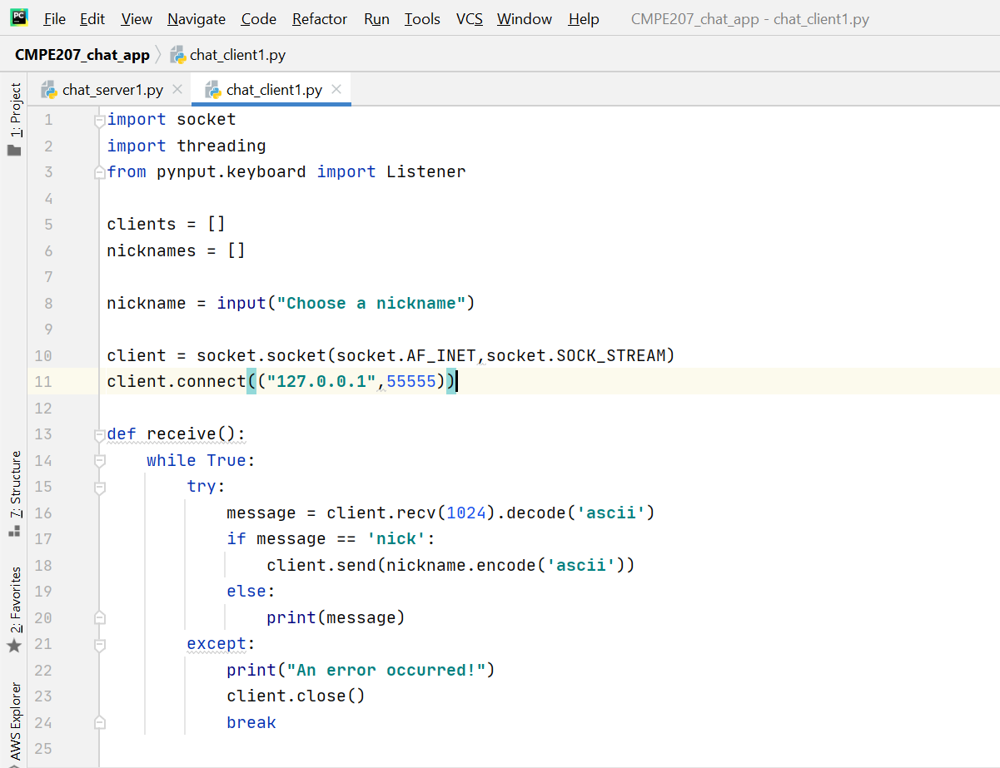

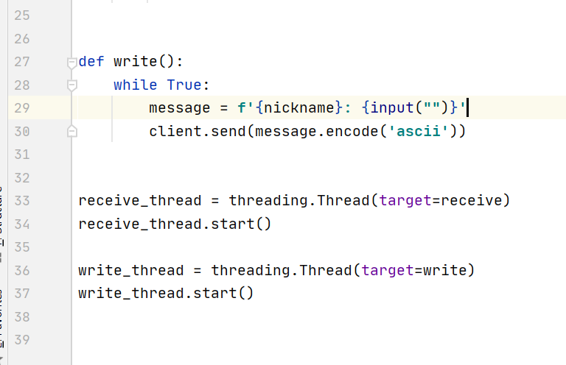

**Output :**

**Server room:**

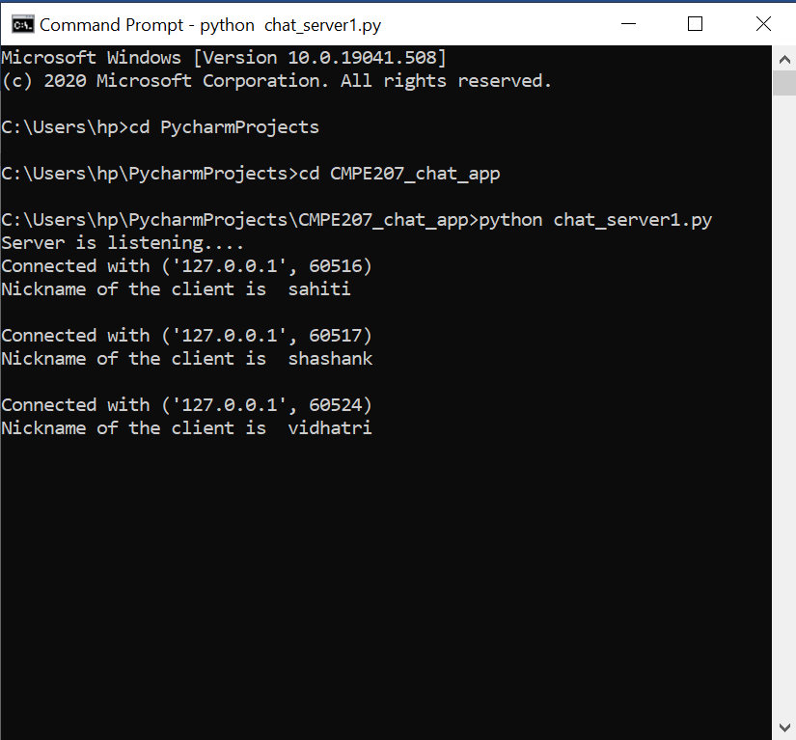

**Client rooms:**

**All in one frame :**

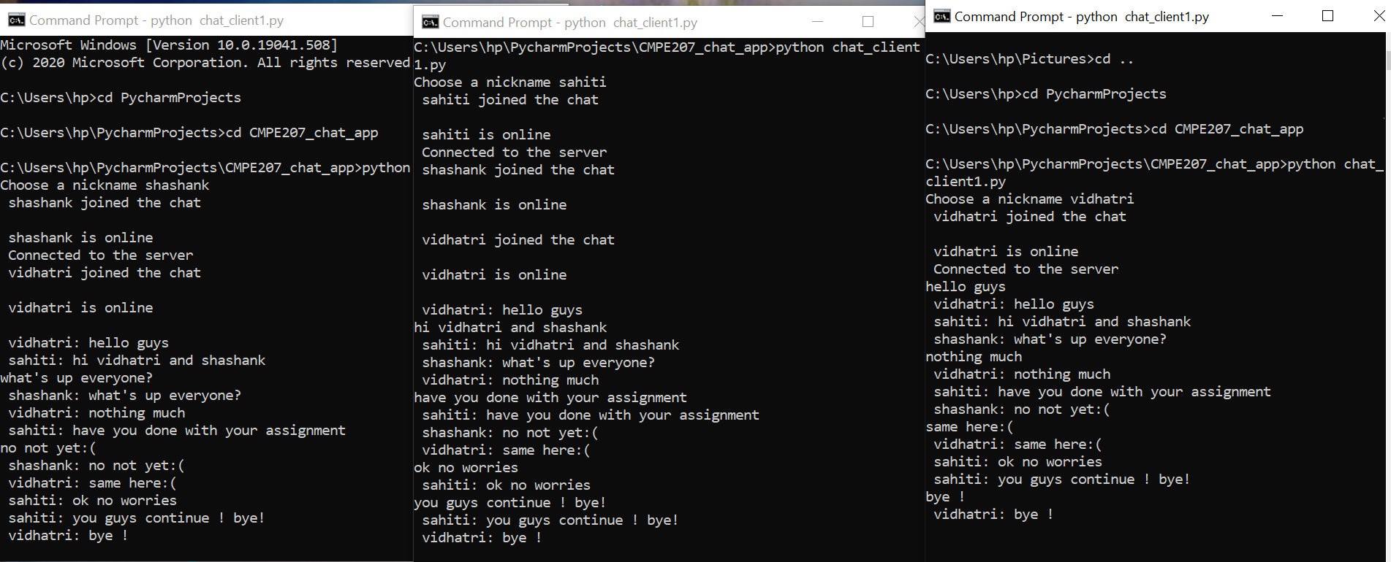

**Separate :**

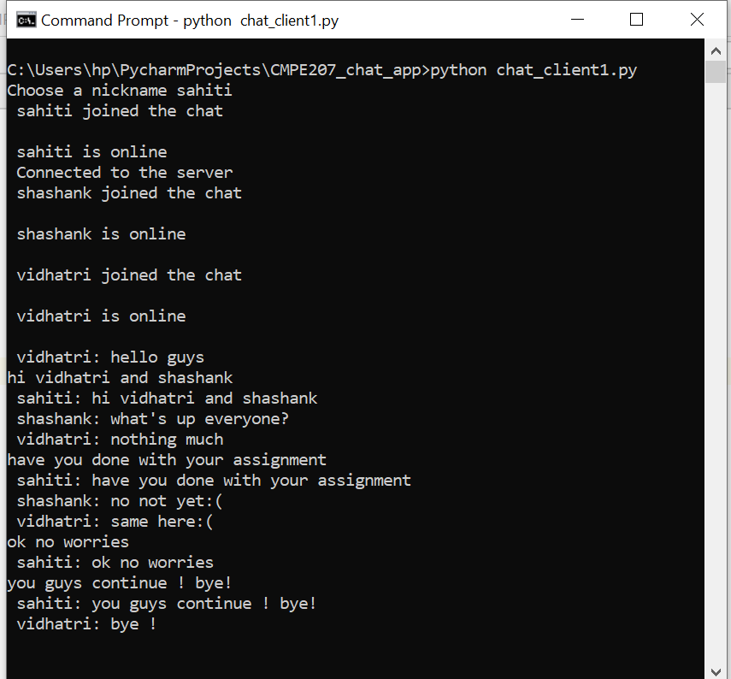

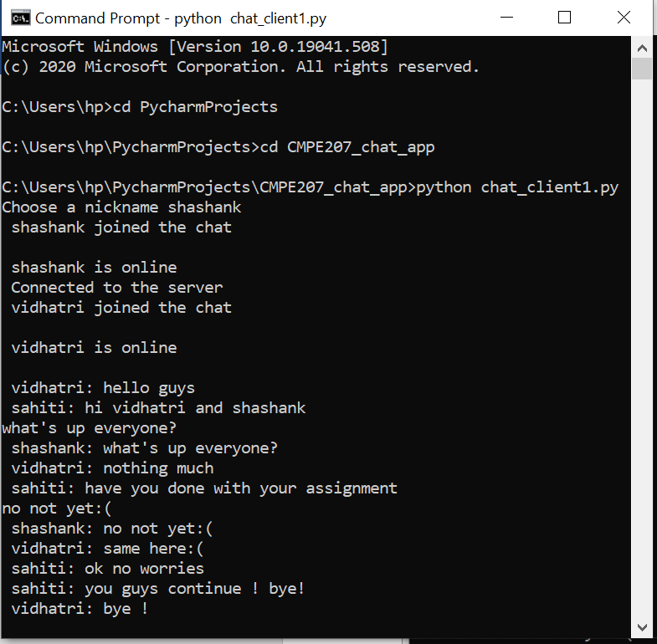

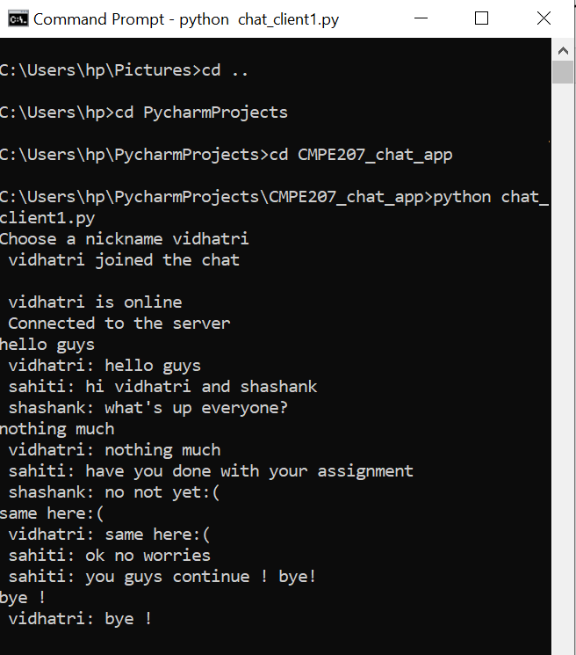

**“User is typing” functionality:**

**Code :**

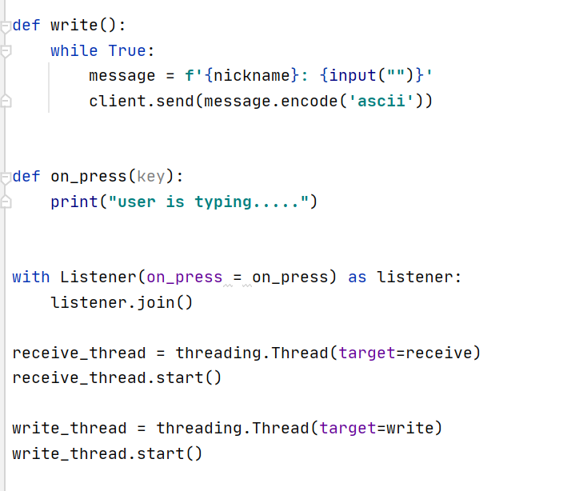

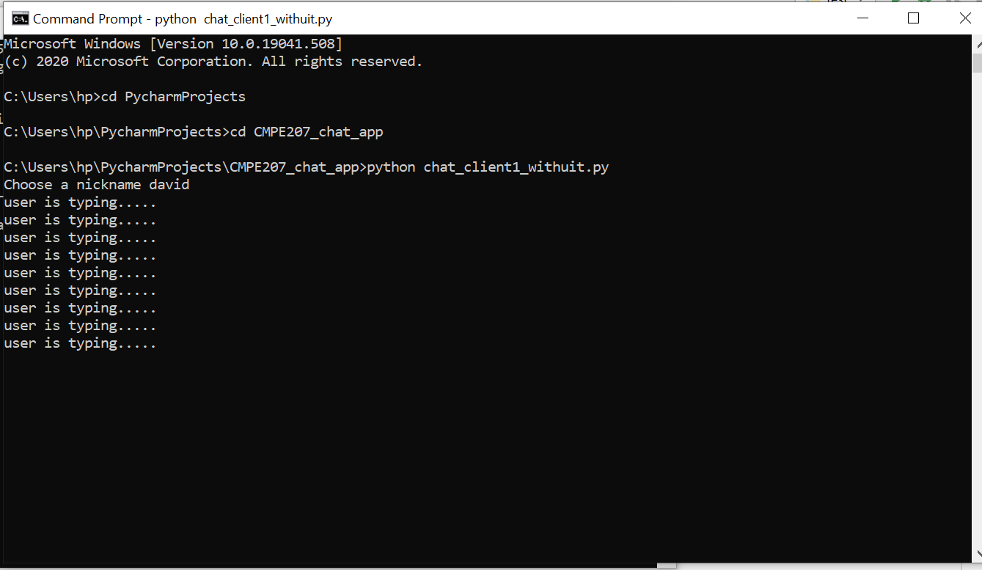

**Source code:** <https://github.com/Shashank-Bheemanapalli/Network-ProgrammingProjects.git>